**Monitoring Criteria and Scores – RAT**

|  |  |  |  |
| --- | --- | --- | --- |
| **General criteria** | **0** | **1** | **2** |
| Activity – i.e. movement around the cage  Bright, Alert, Responsive (BAR) | Normal – mobile and active | Somewhat and/or intermittent stillness as compared to others | Will only move if approached or reluctant to move when touched. Moderately reduced activity, dull, lethargic |
| Body Posture | Normal | Somewhat and/or intermittent hunched appearance | Moderate/continuous hunching and still |
| Social Behaviour  (only relevant for group housed animals) | Normal | Somewhat or intermittently separate from others | Completely separate or isolated from others |
| Coat quality/Skin condition | Normal. Coat flat and glossy, showing evidence of normal grooming behaviour | Somewhat ruffled or unkempt or mild piloerection. Somewhat scaly, scurfy or reddened or discolouration of skin. | Moderately ruffled or moderate piloerection consistent with failure to groom. Moderate scale and scurf, scratches or moderate discolouration of skin. |
| Body Condition  (see diagram below) | Animal is well-conditioned. Vertebrae and dorsal pelvis not prominent; palpable with slight pressure.  (see diagram BC 3) | NA | Animal is under conditioned. Segmentation of vertebral column evident. Dorsal pelvic bones readily palpable. (see diagram BC 2) |
| Facial Expression  (see diagram below) | Normal | Slight or intermittent narrowing of the eyes and/or flattening of the ears. (as per diagram) | Moderate narrowing of the eyes and/or flattening of  the ears. (as per diagram) |
| **Other presenting signs/symptoms**  **Although the most relevant monitoring criteria have been selected, if a circumstance arises where there are additional presenting signs or behaviours, these must be acknowledged, scored, recorded and reported to the AWO as an adverse event.** | | Slight or intermittent or possible deviation from normal for this sign. | Moderate or consistent or definite deviation from normal but not marked, for this sign. |

**EYES**

**EARS**

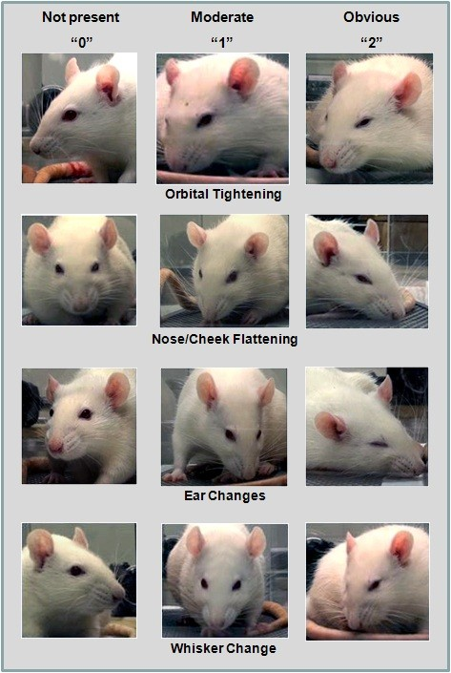

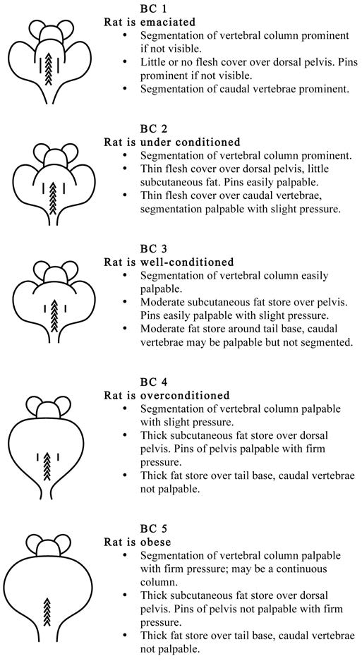

Sotocinal et al. The Rat Grimace Scale: A partially automated method for quantifying pain in the laboratory rat via facial expressions. Molecular Pain 2011, 7:55

Hickman DL, Swan M. Use of body condition scordre techniques to assess health status in a rat model of polycystic kidney disease. JAALAM 49 (2) 2010: 155-159

Sotocinal et al. The Rat Grimace Scale: A partially automated method for quantifying pain in the laboratory rat via facial expressions. Molecular Pain 2011, 7:55

Hickman DL, Swan M. Use of body condition scordre techniques to assess health status in a rat model of polycystic kidney disease. JAALAM 49 (2) 2010: 155-159

Hickman DL, Swan M. Use of body condition scordre techniques to assess health status in a rat model of polycystic kidney disease. JAALAM 49 (2) 2010: 155-159